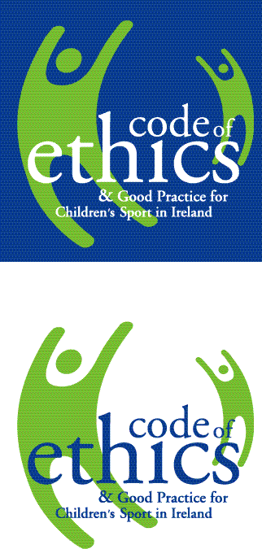
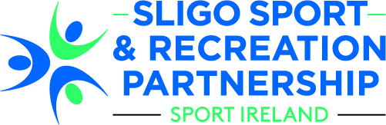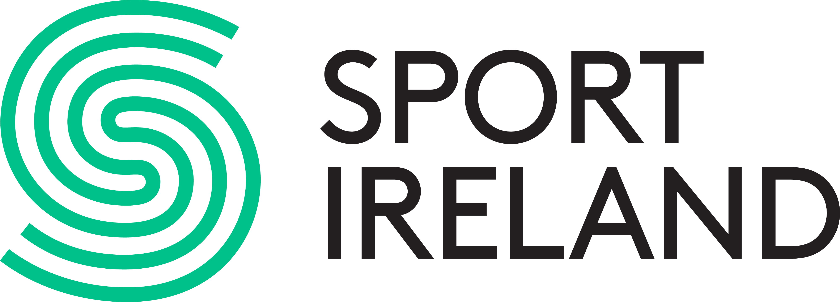

Safeguarding 1, Basic Awareness Workshop

Child Welfare & Protection in Sport

Monday 12th March 2018
6.30pm – 9.30pm (3 hours)
Sligo Education Centre, (on campus of IT Sligo), Ballinode, Sligo
Fee: €15 per person

Sligo Sport and Recreation Partnership will be hosting a ‘Safeguarding 1 Basic Awareness course on Child Welfare and Protection in Sport’. The Code of Ethics is built upon a number of core principles relating to the importance of childhood, the needs of the child, integrity & fair play, relationships and safety in children’s sport. The course is for the benefit of everyone involved in sport for young people including coaches, sports leaders, parents/guardians etc.

This 3 hour Basic Awareness course has been devised by and is certified by Sport Ireland and aims to effectively educate participants on the implementation of best practice in protecting the welfare of children involved in sport.

Limited places are available on the course and pre booking is essential as it is on a first come first served basis. Each individual must fill out an application form and return it, with fee, to the address below by Friday 2nd March 2018. For more information contact Sligo Sport and Recreation Partnership at 071–91 61511 or info@sligosportandrecreation.ie

NOTE: PARTICIPANTS MUST BE 18 YEARS OF AGE TO COMPLETE THIS COURSE

Return address: Sligo Sport and Recreation Partnership, MSL ETB, Quay Street, Sligo
-------------------------------------------------------------------------------------------------------------------
Application Form
Name of Course: Safeguarding 1, Basic Awareness Workshop
Dates/Times: Monday 12th March 2018, 6.30pm -9.30pm
Venue: Sligo Education Centre, IT Sligo Campus Ballinode, Sligo
NOTE: PARTICIPANTS MUST BE 18 YEARS OF AGE

Name:

Address:

Telephone No:

Email:

Club/Group:

Fee enclosed: € €15 per person (Fees are non refundable, non-transferable)

