NOMINATION FORM
SLIGO COUNTY COUNCIL
Cathaoirleach’s
Awards 2019
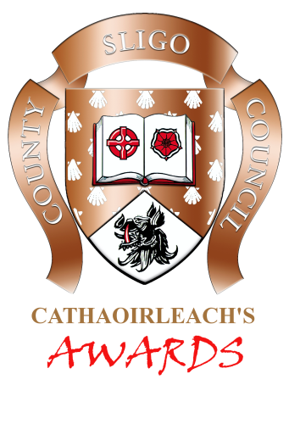
Awards Committee:
Cathaoirleach Cllr.Tom MacSharry
Cllr. Rosaleen O’Grady ~ Cllr. Thomas Walsh
Cllr. Gino O’Boyle ~ Cllr. Chris MacManus
Cllr. Declan Bree ~ Cllr. Marie Casserly ~ Cllr Joe Queenan

Please read the conditions of the Awards before completing the application form

PROFILE OF NOMINATED INDIVIDUAL/GROUP CATEGORY (please tick)
Name: |  | Arts & Culture
 |  | Young Enterprise
Address: |  | Environment/Heritage
 |  | Community (Individual)
 |  | Community (Group)
 |  | Spirit of Sligo Award
 |  | Sports
Telephone: |  | Schools (group/class)

Please outline your reasons for nominating the person or group on Page 2.
If the space provided is insufficient, please attach further information/documentation.

PROFILE OF NOMINATING PERSON/GROUP
Name:
Address:
Telephone:
Signature:
Date:

Please return completed application forms to:
Cathaoirleach’s Awards, Corporate Services, Sligo County Council, Riverside, Sligo
Closing Date: Thursday 21st November 2019
For further information, contact Corporate Services, Sligo County Council. 071 – 911 1111
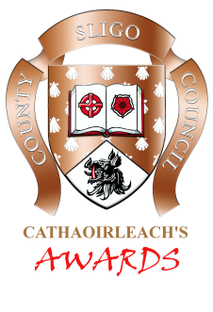
NOMINATION FORM
SLIGO COUNTY COUNCIL
Please outline your reasons for nominating the person or group

Please return completed application forms to:
Cathaoirleach’s Awards, Corporate Services, Sligo County Council, Riverside, Sligo
Closing Date: Thursday 21st November 2019
For further information, contact Corporate Services, Sligo County Council. 071 – 911 1111
Cathaoirleach’s
Awards 2019

Background to the Awards
Sligo County Council recognise the work that the Community and Voluntary sector carry out on a day to day basis and believes that this grouping is one of the most important sectors in the county as they contribute to the “Quality of Life” of all citizens. Therefore, every year the Council distributes grants and provides assistance to various community and voluntary groups.

Cathaoirleach Awards 2019
The Cathaoirleach’s Awards honour volunteers who have given special service to their community in County Sligo. The awards recognise the role played by many individuals and groups in helping to create a strong and vibrant community.

Outlined below are the Categories of awards for 2019. These categories attempt to capture the diverse nature of the activities undertaken at ground level in the area of community and voluntary activity in Sligo.

Award Categories
- Arts and Culture
- Young Enterprise
- Environment/Heritage
- Community (individual)
- Community (group)
- Spirit of Sligo Award
- Sports
- Schools (group/class)

The Cathaoirleach’s Awards go some way to recognising the involvement of individuals and groups in their communities, how they can influence others to become involved and active in their communities.

Awards Committee
An Awards Committee will review all nominations received and will select winners based on the information submitted on the official application form. The Awards Committee Members are:

Cathaoirleach Cllr. Tom MacSharry, Cllr. Rosaleen O’Grady, Cllr. Thomas Walsh, Cllr. Gino O’Boyle, Cllr. Chris MacManus, Cllr. Declan Bree, Cllr Marie Casserly, Cllr Joe Queenan

Conditions of the Awards

- Nominations can only be accepted on the official application form
- Groups or individuals will be considered for voluntary work only
- Nominations can be accepted for individuals in more than one category
- An individual or group cannot nominate themselves
- Elected Members or staff of Sligo County Council are not eligible to receive an award
- Closing date for receipt of nominations: Thursday 21st November 2019

