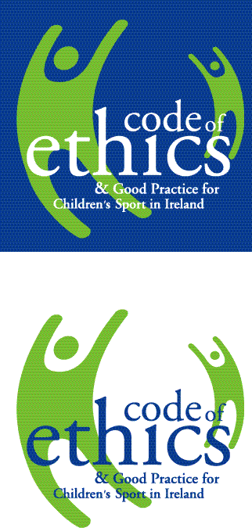


Safeguarding 2, Club Children’s Officer Course

Child Welfare & Protection

Tuesday3rd December 2019
6.30pm – 9.30pm (3 hours)
Sligo Education Centre, (on campus of IT Sligo), Ballinode, Sligo
Fee: €15 per person

Sligo Sport and Recreation Partnership will be hosting a Club Children’s Officer Course as part of club training on the ‘Code of Ethics and Good Practice for Children’s Sport’. This Club Children’s Officer’s course presents a great opportunity for sports clubs to lead the way in terms of models of good practice for children’s sport. The training will provide information and resources on how to put in place effective Child Protection measures in your sports club.
Recommendations from Sport Ireland are that every club involved with children and young people should appoint a Children's Officer. This person should be child centred in focus and should have as their primary aim the establishment of a child centred ethos within the club. They are the link between the children and the adults in the club and also take responsibility for monitoring and reporting to the Club Management Committee on how club policy etc, impacts on children and their Sports Leaders.

NOTE: It is essential that those who wish to attend the training have attended the Sport Ireland Safeguarding 1 Basic Awareness Course. Please supply the Certificate Number and Course Date of the Sport Ireland Safeguarding 1 Basic Awareness Course you have previously completed. Limited places are available on the course and pre booking is essential as it is on a first come first served basis. Each individual must fill out an application form and return it, with fee, to the address below by Friday 8th November 2019. For more information contact Sligo Sport and Recreation Partnership at 071–91 61511 or info@sligosportandrecreation.ie

NOTE: PARTICIPANTS MUST BE 18 YEARS OF AGE TO COMPLETE THIS COURSE
Return address: Sligo Sport and Recreation Partnership, MSL ETB, Quay Street Sligo.
-------------------------------------------------------------------------------------------------------------------
Application Form
Name of Course: Safeguarding 2, Children’s Officer Course
Dates/Times: Tuesday 3rd December 2019 6.30pm -9.30pm
Venue: Sligo Education Centre, IT Sligo Campus Ballinode, Sligo
NOTE: PARTICIPANTS MUST BE 18 YEARS OF AGE

Name:

Address:

THE FOLLOWING MUST BE COMPLETED (*)
Safeguarding 1 (Awareness) Cert. No.: (*) (*) Course Date:
Telephone No:

Email:

Club/Group:
Fee enclosed: € €15 per person (Fees are non refundable, non-transferable)

I CONSENT TO MY DETAILS BEING USED BY SSRP FOR FUTURE COMMUNICATIONS: Yes No

