First Name:
Last Name:
Date of birth:
Address:
Email address:
Work Phone:
Mobile Phone:
Role in Sports and Physical Activity:
Do you have a disability or any special requirements you would like to make us aware of?
Reason for attending the workshop?
Are there any specific questions you would like answered on the training day?
Fee Enclosed €35 | Cash Cheque
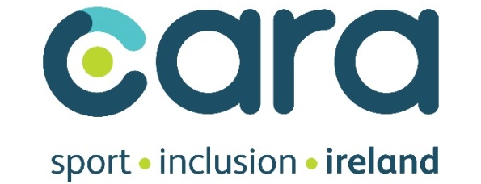

DISABILIY INCLUSION TRAING WORKSHOP – SLIGO 23rd NOVEMBER 2019
BOOKING FORM

