You’ve completed the first week of your 5km training plan- WELL DONE!

Whether you are new to running or a speed queen hoping to run sub 25minutes, the food you eat matters. Nutrition plays a vital role in your recovery from exercise and your subsequent performance.

I’ve put together a list of convenient foods to help with your recovery after your run. Try to eat something from this list within 30-45 minutes after training.

- Chocolate Milk- tastes delicious and is a great source of protein and carbohydrate to help refuel and repair exhausted muscles. Super handy when you’re on the go too! Some products may have a high sugar content, read your labels!

- Bananas- provide you with carbohydrates to replenish muscle fuel. They’re a good source of potassium too, an electrolyte you may lose through sweat when you’re running. Enjoy one on its own or try blending with some milk, berries, peanut butter and honey for a tasty nutritious smoothie.

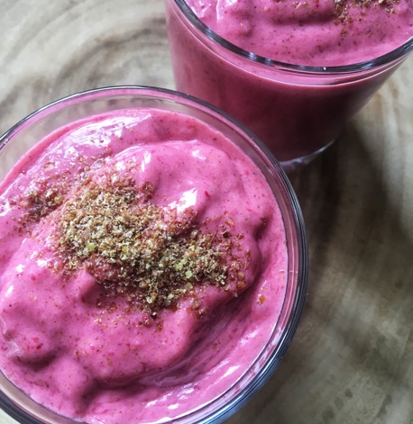

- Nut Butters- are a fantastic source of protein and healthy fats. They are also packed with B Vitamins which your body uses to release energy from food. Try snacking on apple slices with 1 Tbsp of peanut butter and a sprinkle of cinnamon, or 6 oatcakes with 2 Tbsp of almond butter and strawberry slices. Yum!

- Yoghurt- rich in protein, carbohydrate and calcium. Add some berries, honey or granola for some extra carbs, fiber and antioxidants. Some contain healthy bacterial cultures which are great for your gut health and overall wellbeing.

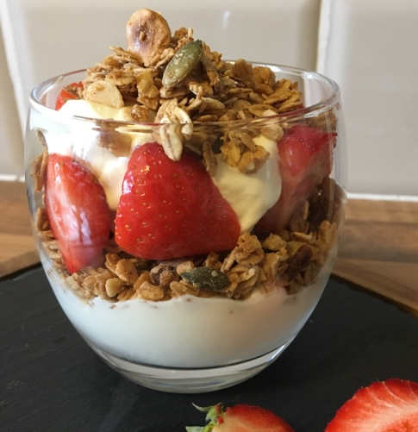

- Homemade Bars- are a great option for delivering fast and convenient nutrients that will keep you going until its time for your next meal (you can follow me on Instagram @_inspiredbysj for recipe ideas).

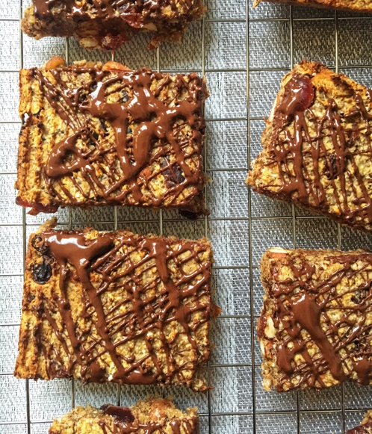

When you have more time on your hands and are ready for a substantial meal (2-4hours after training) try;

- Baked salmon with rice and stir-fried vegetables (salmon is a good source of omega-3 fatty acids which can help reduce inflammation).
- Baked beans on toast (beans provide protein and fiber along with iron which is essential for transporting oxygen around your body).
- Chicken fajitas with vegetables (add some ginger and turmeric to your spice mix as they have anti-inflammatory properties).
- Frittata made with vegetables and cheese (a great recovery meal packed with carbs, protein and essential vitamins and minerals).

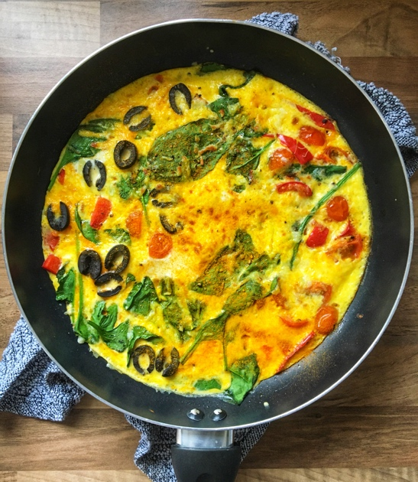

Best of luck with next week’s training plan and stay tuned for more Nutrition tips, Sarah-Jayne

